# Introduction to Back-tracking

Backtracking is used when we have multiple solutions and we want all the solutions. Backtracking follows Brute-force approach.

# N-Queen problem

***# Python3 program to solve N Queen***

***# Problem using backtracking***

***global N***

***N = 4***

***def printSolution(board):***

***for i in range(N):***

***for j in range(N):***

***print (board[i][j], end = " ")***

***print()***

***def isSafe(board, row, col):***

***# Check this row on left side***

***for i in range(col):***

***if board[row][i] == 1:***

***return False***

***# Check upper diagonal on left side***

***for i, j in zip(range(row, -1, -1),***

***range(col, -1, -1)):***

***if board[i][j] == 1:***

***return False***

***# Check lower diagonal on left side***

***for i, j in zip(range(row, N, 1), range(col, -1, -1)):***

***if board[i][j] == 1:***

***return False***

***return True***

***def solveNQUtil(board, col):***

***# base case: If all queens are placed***

***# then return true***

***if col >= N:***

***return True***

***# Consider this column and try placing***

***# this queen in all rows one by one***

***for i in range(N):***

***if isSafe(board, i, col):***

***# Place this queen in board[i][col]***

***board[i][col] = 1***

***# recur to place rest of the queens***

***if solveNQUtil(board, col + 1) == True:***

***return True***

***# If placing queen in board[i][col***

***# doesn't lead to a solution, then***

***# queen from board[i][col]***

***board[i][col] = 0***

***# if the queen can not be placed in any row in***

***# this colum col then return false***

***return False***

***# This function solves the N Queen problem using***

***# Backtracking. It mainly uses solveNQUtil() to***

***# solve the problem. It returns false if queens***

***# cannot be placed, otherwise return true and***

***# placement of queens in the form of 1s.***

***# note that there may be more than one***

***# solutions, this function prints one of the***

***# feasible solutions.***

***def solveNQ():***

***board = [ [0, 0, 0, 0],***

***[0, 0, 0, 0],***

***[0, 0, 0, 0],***

***[0, 0, 0, 0] ]***

***if solveNQUtil(board, 0) == False:***

***print ("Solution does not exist")***

***return False***

***printSolution(board)***

***return True***

***# Driver Code***

***solveNQ()***

# **Sum of Subsets**

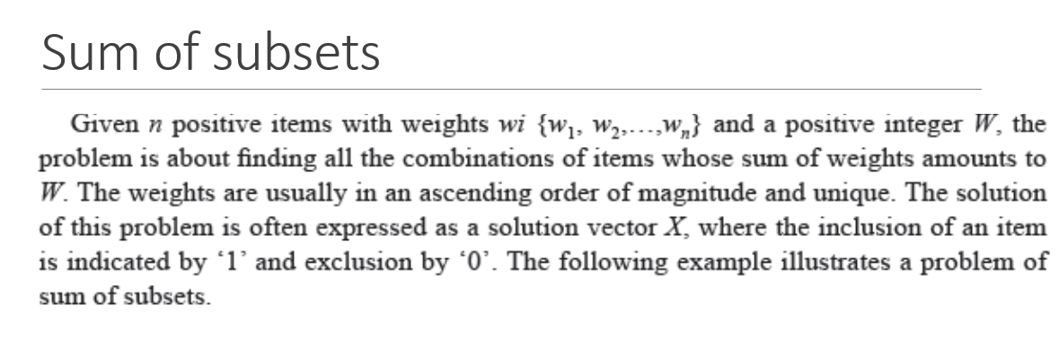

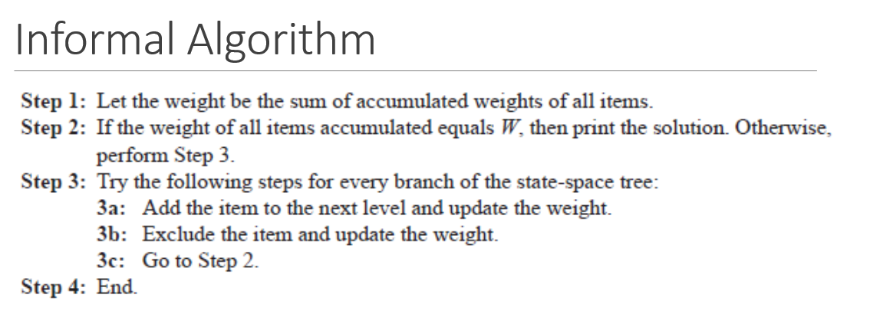

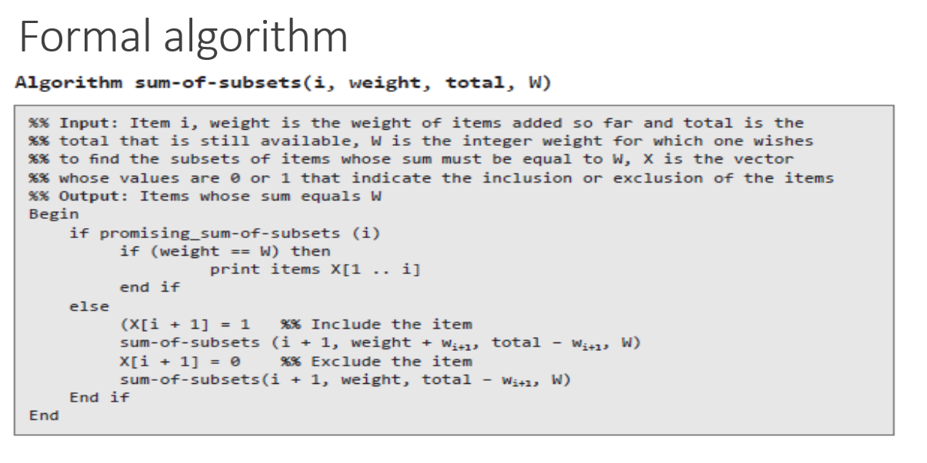

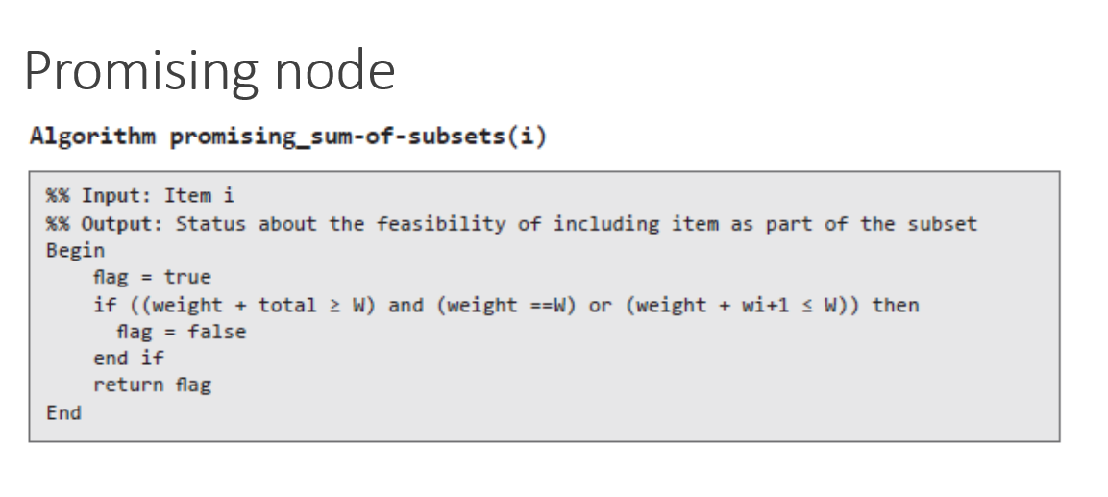

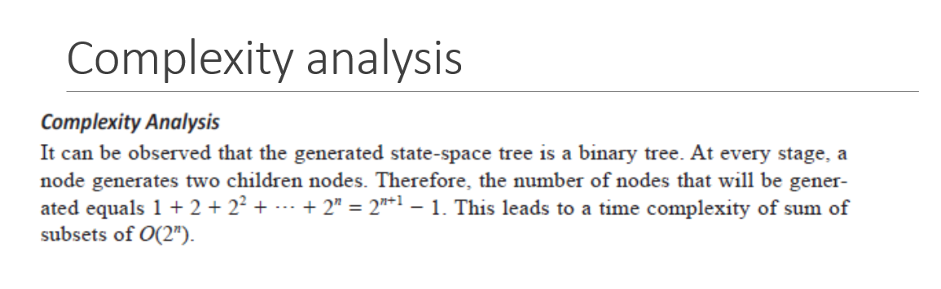

# Graph colouring problem

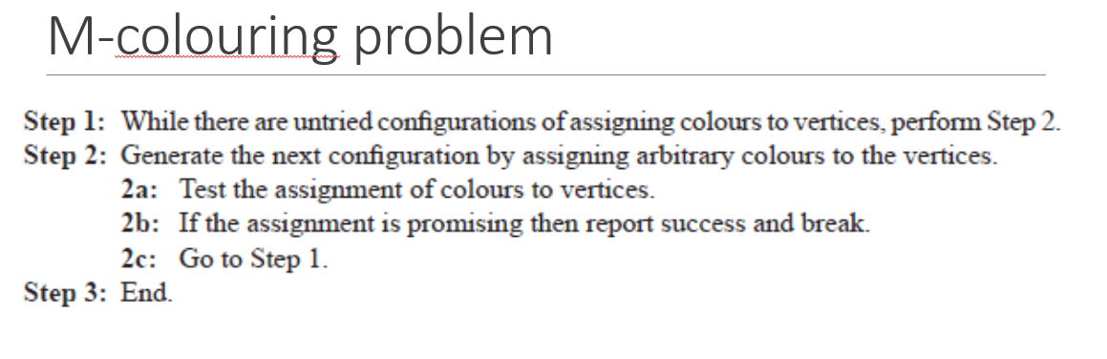  
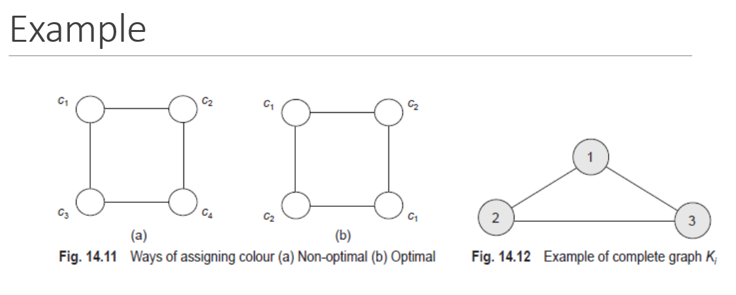

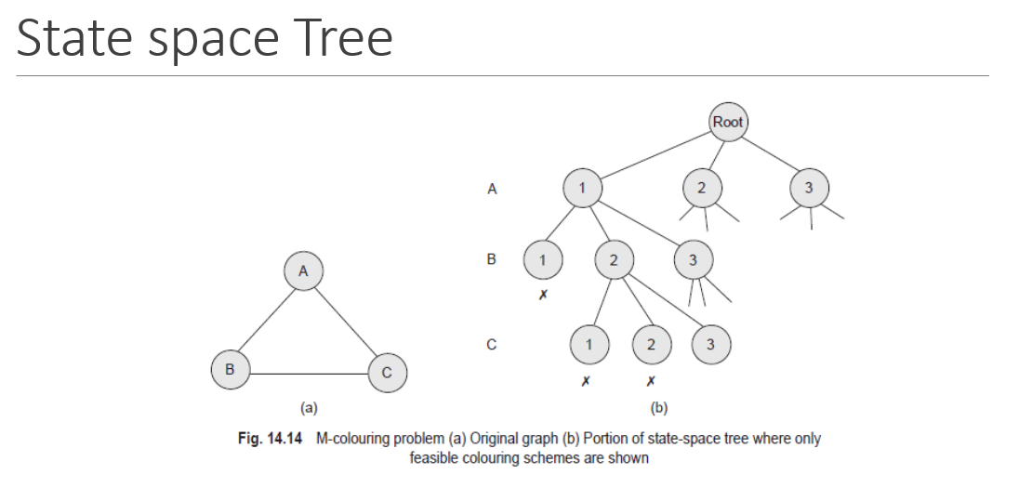

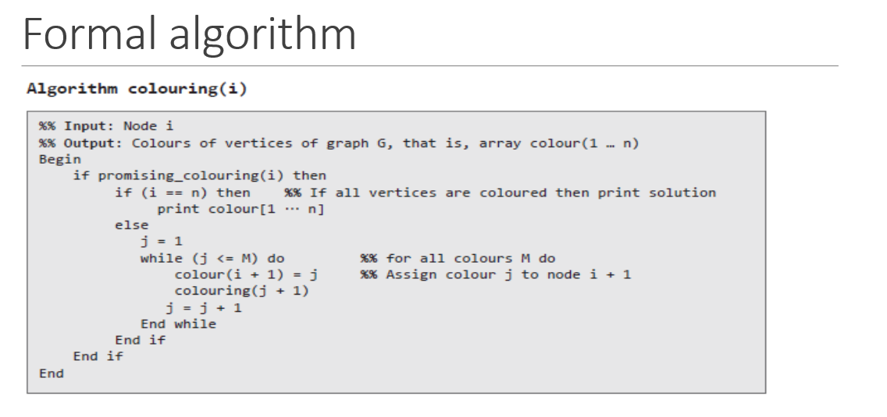

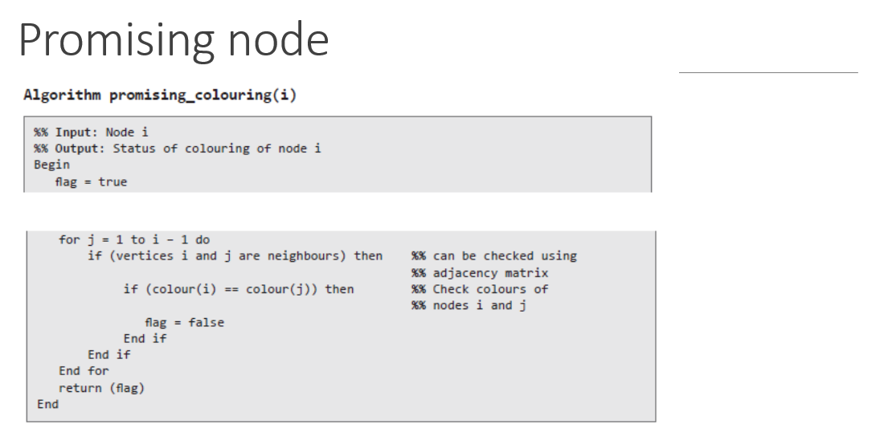

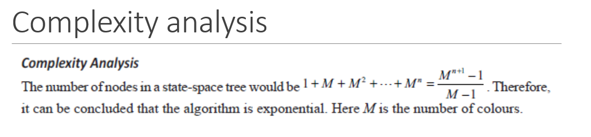

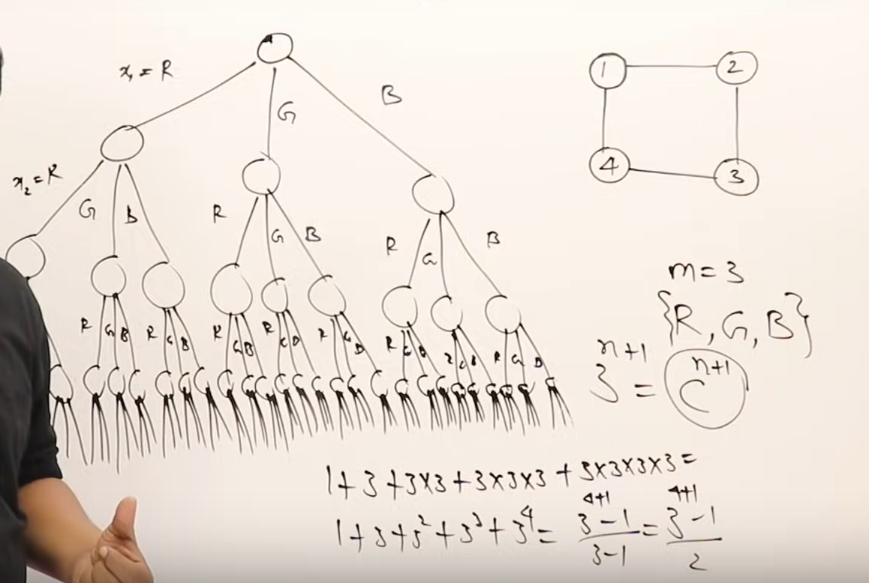

# Hamiltonian cycle / Hamiltonian circuit

* Hamiltonian path is an undirected graph that visits each and every vertex exactly only once.
* This Hamiltonian cycle/circuit is a Hamiltonian path such that there is an edge (in the graph) from the last vertex to the first vertex of the Hamiltonian path.
* Problem 🡪 Determine whether a graph contains Hamiltonian cycle / not. If it contains the Hamiltonian path is printed.

